|  |  |
| --- | --- |
| Name: | Prerna Sunil Jadhav |
| Sap Id: | 60004220127 |
| Class: | T. Y. B. Tech (Computer Engineering) |
| Course: | Information Security Laboratory |
| Course Code: | DJ19CEL603 |
| Experiment No.: | 10 |

**AIM:** Perform Packet Capture and Sniff IP traffic using Wireshark.

Capturing ICMP Packets:

C:\Users\Marwin Shroff>ping 8.8.8.8 Pinging 8.8.8.8 with 32 bytes of data: Reply from 8.8.8.8: bytes=32 time=5ms TTL=119

Reply from 8.8.8.8: bytes=32 time=6ms TTL=119 Reply from 8.8.8.8: bytes=32 time=2ms TTL=119

Reply from 8.8.8.8: bytes=32 time=3ms TTL=119 Ping statistics for 8.8.8.8:

Packets: Sent = 4, Received = 4, Lost = 0 (0% loss), Approximate round trip times in milli-seconds: Minimum = 2ms, Maximum = 6ms, Average = 4ms

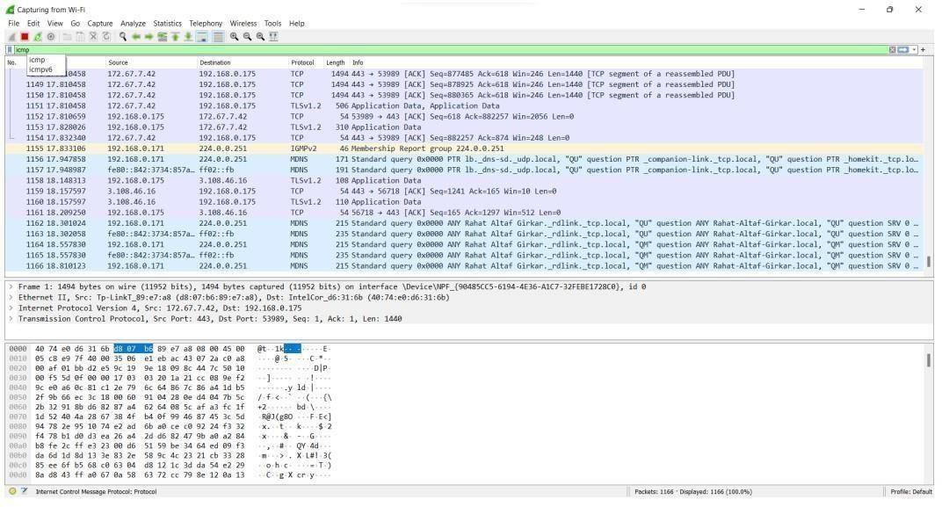

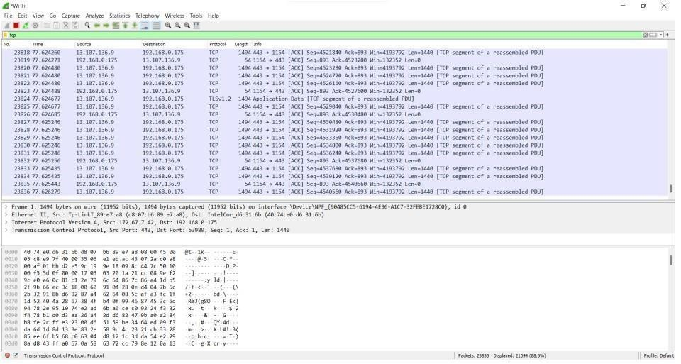Capturing TCP Packets:

Capturing FTP Packets:

C:\Users\Marwin Shroff>ftp ftp.cdc.gov Connected to ftp.cdc.gov. 220 Microsoft FTP Service

200 OPTS UTF8 command successful - UTF8 encoding now ON. User (ftp.cdc.gov:(none)): anonymous

331 Anonymous access allowed, send identity (e-mail name) as password. Password: 230 User logged in.

ftp> ls

200 PORT command successful.

150 Opening ASCII mode data connection.

.change.dir .message pub Readme

Siteinfo w3c welcome.msg 226 Transfer complete. ftp: 67 bytes received in 0.03Seconds 2.03Kbytes/sec.

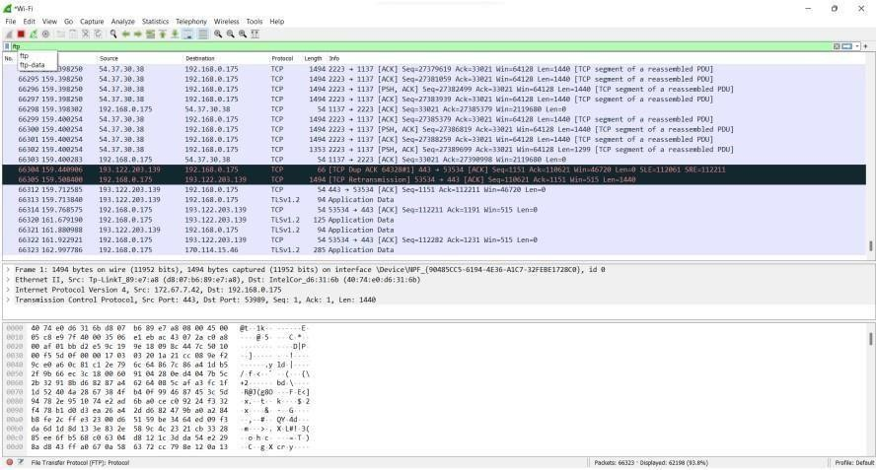

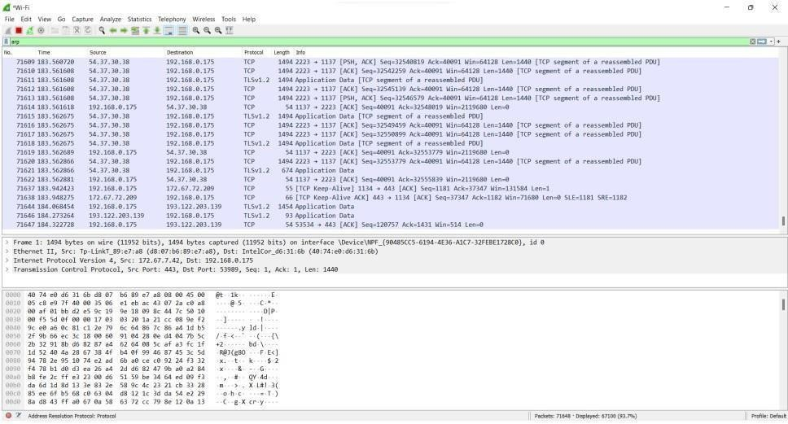Capturing ARP Packets:

B] Tracing Packets based on filters: 1] Filter Results by Port:

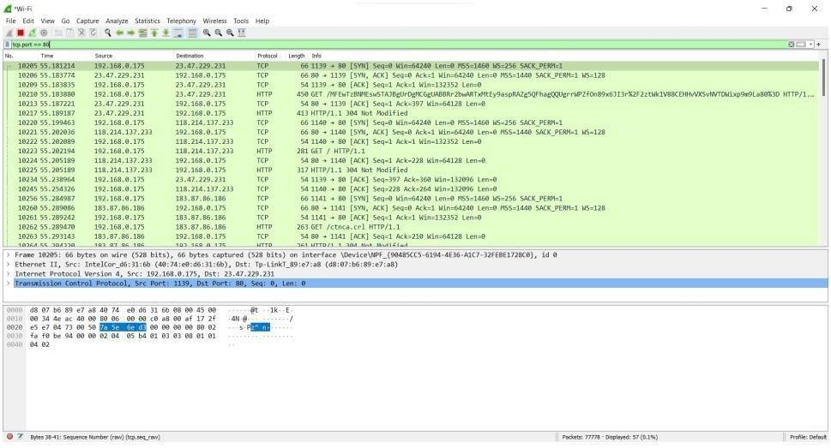Traces all packets related to Port 80.

1. Filter by Delta Time :

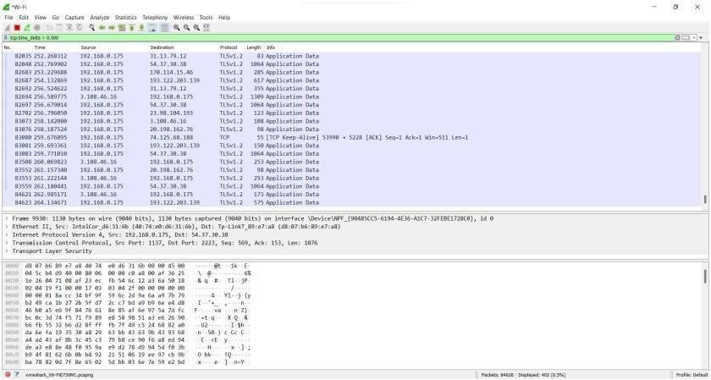Displays tcp packets with delta time of greater than 0.500 sec

1. Filter by Byte Sequence:

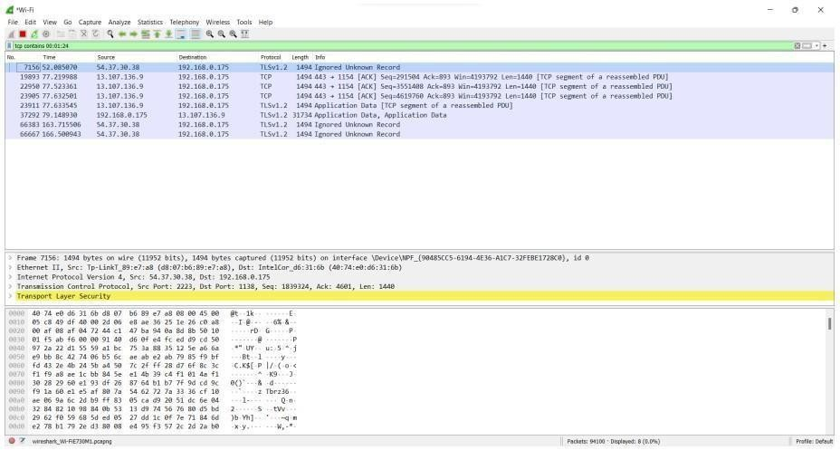Displays packets which contain a particular byte sequence.

1. Filter by Source IP Address:

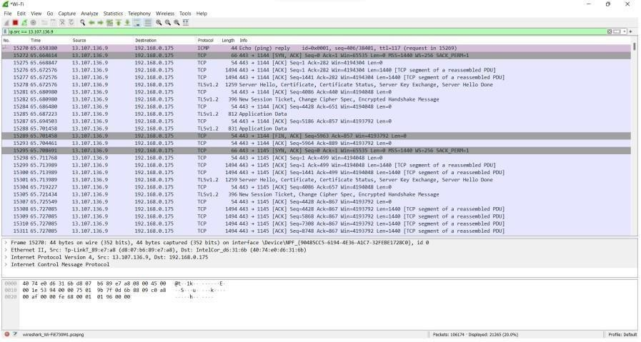Displays packets which have source IP address same as the one provided in the argument.

**CONCLUSION:** Thus, we have successfully studied packet sniffing tools (Wireshark) and explored how packets can be traced based on different filters